**EXPOSYS DATA LABS**

**Name: Dhiraj Kumar Shastri**

**Web Development Task:**

Create a Multi-Page Responsive Website.

**GETFIT**

FITNESS GYM RESPONSIVE WEBSITE

ABSTRACT

Software developers can use responsive design to create a Web page that adapts to the size of the device in real-time. This approach to development allows Web pages to be rendered quickly and efficiently, resulting in a positive user experience on mobile, tablet, and desktop platforms.

The purpose of this project is to design a Responsive website that consists of all the information regarding the Get fit gym like the environment, plans, facilities, etc and all the extra information that is needed. And even the contact facility is been provided so that the user can get all their queries solved.

Table of Contents

**CHAPTERS PAGE NO.**

* **Chapter 1 Introduction 4**

* **Chapter 2 Existing Method 6**
* **Chapter 3 Proposed method with Architecture 8**
* **Chapter 4 Methodology 10**
* **Chapter 5 Implementation 14**
* **Chapter 6 Conclusion 20**

Chapter 1. Introduction

Web pages are one way to share information over the internet. When designing a web page, you need to start by figuring out what type of content you want to present to your audience. To design an attractive site, it's helpful for people who understand how browsers display web pages and how people read them on their screens. Web pages are the simplest way to share your thoughts, ideas, and products with your customers. It's important that web pages are designed well to attract, engage and convince visitors.

There are 6 pages and they are – The home page, the About page, the plans page, the Trainers page, the Blog page, and the Contact us page.

The home page is the main landing page through which a user can visit to several other pages by a single click. This page is divided into a few sections.

The about page consists of all the basic information of the gym which includes the organizational information.

The plans page consists of all the pricing for the plans that is been provided by the gym along with the facilities given.

The trainers page consists of all the expert trainer that are certified and provide personal trainings in the gym and their social media handle..

The Blogs page consists of the various fitness activity information to read and get the knowledge about the growing fitness industry.

The contact us page is the last and the most important place a user can come across. It includes all the contact details along with a form through which a user can get all the queries resolved. A confirmation message will be popped once a form will be filled.

As a result, it's important to look into Web design models and techniques that could help to mitigate some of the challenges mentioned above. One of the most common strategies is responsive Web design, which allows a website to adjust to the device that is being used to access a page (e.g., desktop, laptop, tablet or a smartphone).

The number of scientific studies in the subject of responsive design is currently quite minimal, and most of them simply compare responsive design to adaptive design and the native process of developing an Android or iOS app.

The majority of studies examining the merits and drawbacks of responsive design are opinion-based, based on the personal experiences of Web and mobile developers. The role of responsive Web design is discussed in this study, as well as the primary reasons for its adoption and the limits experienced by web envelopers.

Chapter 2. Existing Method

If you’re a gym owner, you need a great website. First and foremost, it helps people to find you. Considering that all your competitors already have a website, you’re behind the curve if you don’t have one. It’s not enough to just have a website; it needs to be a great website to establish your business as an authority, help manage your members, and so much more. Here are five reasons you need a great gym website.

The COVID-19 pandemic has forced many people to live a more digital way of working and living. From homeworking to digital fitness, the online world is key to moving forward. Being able to adapt and take advantage of new online opportunities is crucial to success.

You need a strong online presence so that potential members can find you. 81% of people search online for a product or service. Part of a strong online presence is a fully mobile-optimized website. Make it as easy as possible for customers to find you.

Nowadays, customers expect you to have a website. Your website affects how people perceive the quality and credibility of your business. It takes about 50 milliseconds for users to form an opinion of your website. That’s how long it takes for them to decide whether they stick around or go elsewhere.

 The customer expectation is to not only have a website but to have a responsive and compelling website with a crisp layout and design.

Chapter 3. Proposed method with Architecture

HTML is the language that web browsers read and understand to display web content on a user’s screen. It is the most basic set of instructions for telling a browser how to display text, images, videos, and other media on a webpage. HTML is the markup language that web pages are written in. It is a set of tags that are used to create the structure and layout of a webpage. It also provides semantics for content, meaning you can tell what certain elements mean and how they should be styled by your browser.

CSS stands for Cascading Style Sheets, which dictate how HTML elements should look on your screen. CSS can alter aspects like color, position, spacing between elements, or many other features in order to make your website more aesthetically pleasing or functional in some way. CSS (Cascading Style Sheets) is a language used for styling and laying out HTML pages, with which you can control the appearance of an HTML document or parts of it without altering the underlying HTML. Create a Website With HTML and CSS for Beginners

Web pages are the backbone of the internet. They are what everyone sees and interacts with when they visit a website. Web pages can be created using HTML and CSS. Webpage: A web page (or website) can be defined as a document that has been designed to appear when accessed via a web browser. The term "web page" was coined in 1993 by Sir Tim Berners-Lee who invented the World Wide Web.

The purpose and goals of your website will influence many of the decisions you make throughout this process, from the pages you build to the calls-to-action you include to whether you should establish separate consumer and franchise development websites.

You'll be able to determine what content, design, and user experience you want for your franchise website based on the buyer personas you establish and understand. This strategy can also help you figure out why each of your characters prefers your firm over one of your competitors.

|  |
| --- |
| **MODULES OF GETFIT FITNESS WEB:** |
| |  | | --- | | * **HOME** | | * **ABOUT** | | * **PLANS** | | * **TRAINERS** | | * **BLOGS** | | * **CONTACT US** | |

Chapter 4. Methodology

**LANGUAGES USED:**

* HTML – HyperText Markup Language
* CSS – Cascading Style Sheet)
* SAAS – (Syntactically Awesome Stylesheet)
* JS – JavaScript

**FRONT END LANGUAGES:**

HTML:

* + HTML (Hypertext Markup Language) is a markup language used to create webpages and apps. Each page has a series of hyperlinks that connect it to other pages.
  + The HTML tags are not displayed by browsers, but they are used to read the page's content.
  + HTML code guarantees that text and graphics are formatted correctly so that they appear as intended in your web browser.
  + A browser would not be able to display text as elements or load images or other elements without HTML.
  + HTML also supplies the page's basic structure, which is then covered with Cascading Style Sheets to customize its appearance.

CSS:

* + CSS (Cascading Style Sheets) is a style sheet language for specifying the appearance of a document written in a markup language. It was created to allow the separation of presentation and content, including layouts, colors, and fonts.
  + This division can improve information accessibility and provide you greater flexibility and control over the presentation qualities you specify.
  + Enables multiple HTML pages to share formatting by specifying the relevant CSS in a separate .css file, and reduce complexity and repetition in the structural content.
* SAAS:
  + Sass stands for Syntactically Awesome Stylesheet
  + Sass is an extension to CSS
  + Sass is a CSS pre-processor
  + Sass is completely compatible with all versions of CSS
  + Stylesheets are getting larger, more complex, and harder to maintain. This is where a CSS pre-processor can help.
  + Sass lets you use features that do not exist in CSS, like variables, nested rules, mixins, imports, inheritance, built-in functions, and other stuff.

**FRONT END FRAMEWORK:**

JAVASCRIPT:

* JavaScript was initially created to “make web pages alive” .The programs in this language are called scripts.
* They can be written right in a web page’s HTML and run automatically as the page loads.
* Scripts are provided and executed as plain text. They don’t need special preparation or compilation to run.
* In this aspect, JavaScript is very different from another language called Java. It is absolutely free to download and use.

It is a front-end framework used for easier and faster web development.

* It includes HTML and CSS based design templates for typography, forms, buttons, tables, navigation, modals, image carousels and many others.
* It can also use JavaScript plug-ins. It facilitates you to create responsive designs.

**SYSTEM REQUIREMENT**

Hardware Requirements:

* Computer with either Intel Pentium processor or AMD processor.
* 128MB DDR RAM or 40GB hard disk drive

Software Requirements:

* Windows 98/2000/XP operating system.
* Microsoft Visual Studio 6.0

Chapter 5. Implementation

# Webpage layouts:

**Home page:**

* It is the main landing web-page of the website.
* User will be able to choose between the different options in this page.

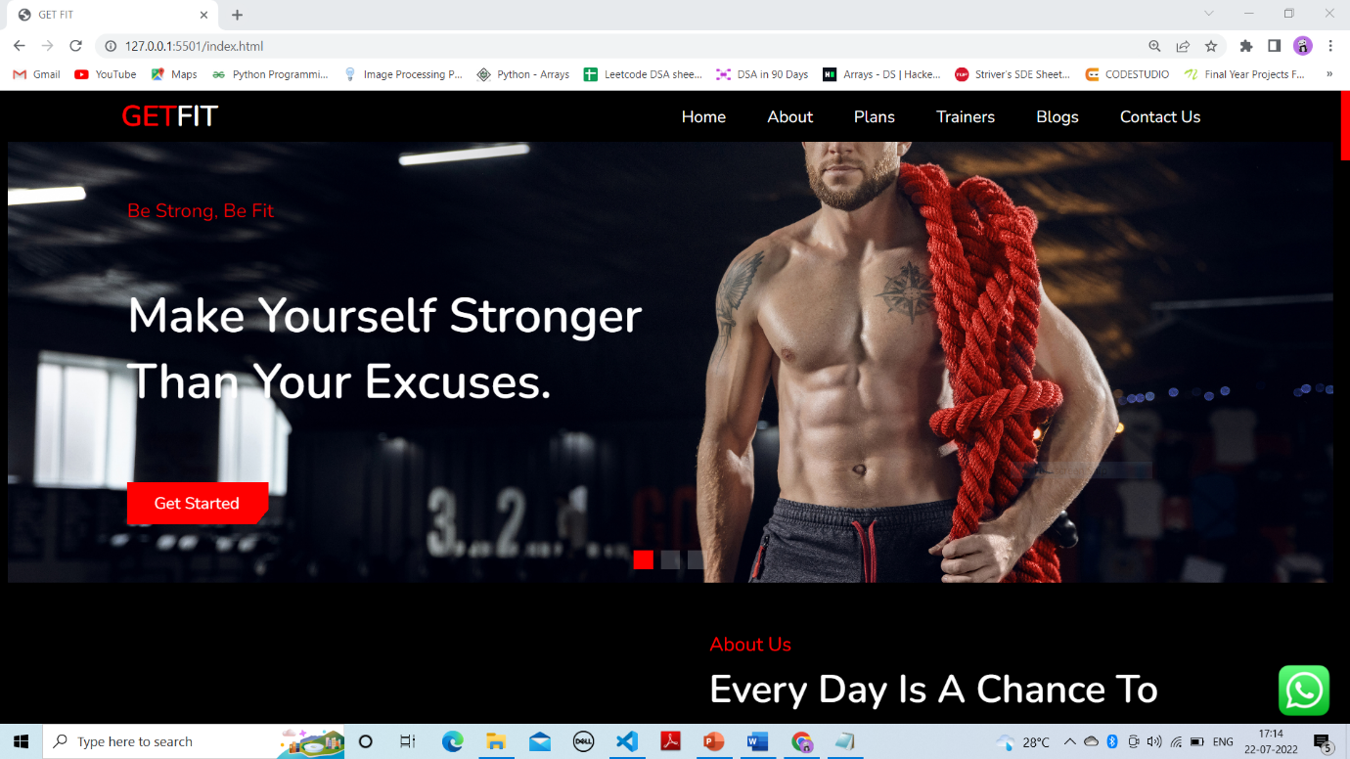

**About us Page:**

* The user can click on the about link to go to the about page.
* This page consists of the gym environment and the organizational information as well.

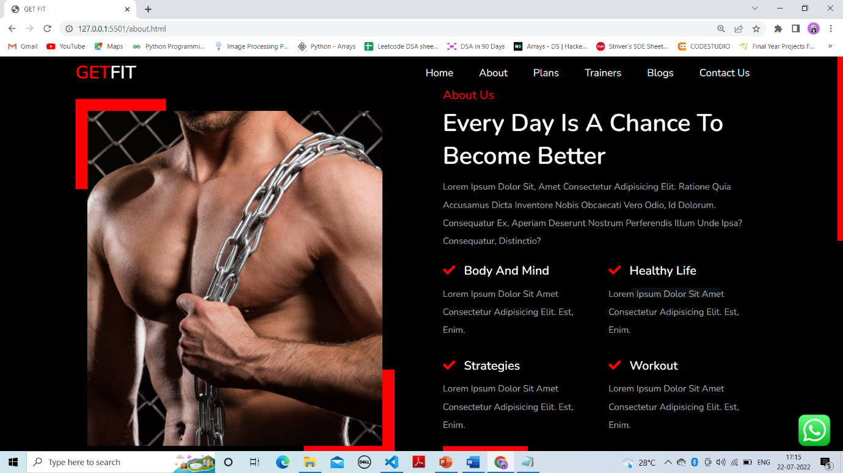

**Plans Page:**

* The user can click on the courses link to visit this page.
* This page consists of the courses that is been provided and even the facilities offered.

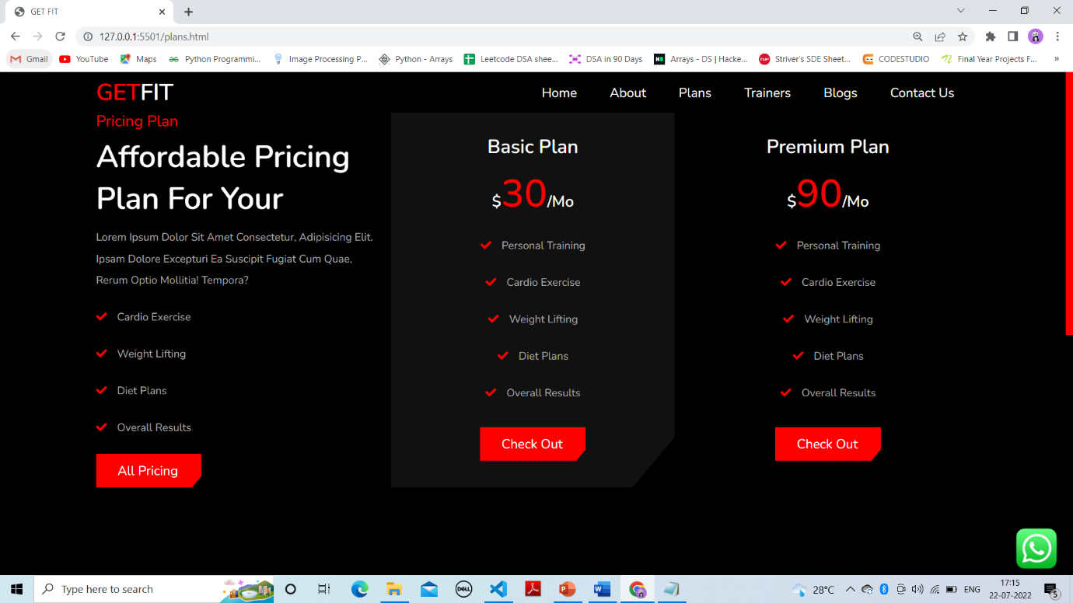

**Trainers Page:**

* This page allows the user to know about the different certifications available and also allows the user to post their comment regarding the university and rate it.

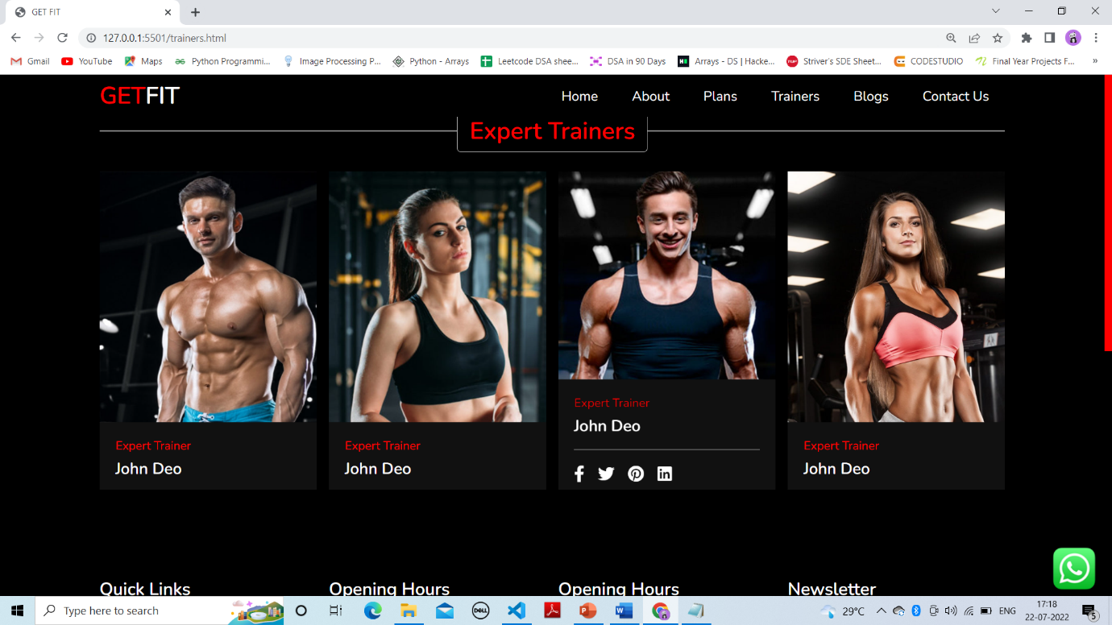

**Blogs page:**

* This page allows the user to know about the different certifications available and also allows the user to post their comment regarding the university and rate it.

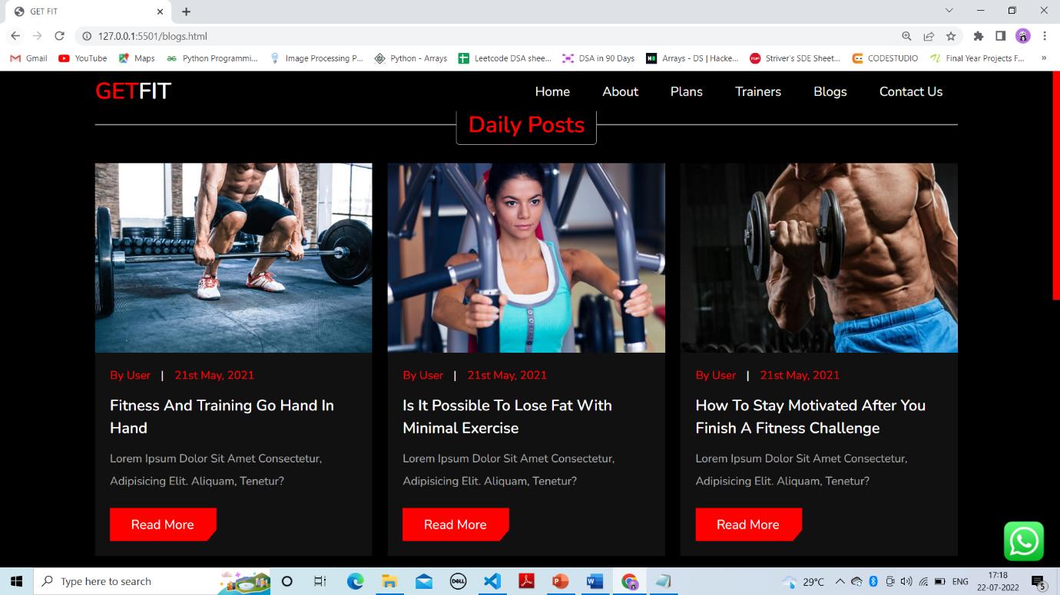

**Contact page:**

* The user can click on the contact link to visit this page.
* It includes all the contact details along with a form through which a user can get all the queries resolved. This is the best facility a user gets with the interactions on the website at the end.

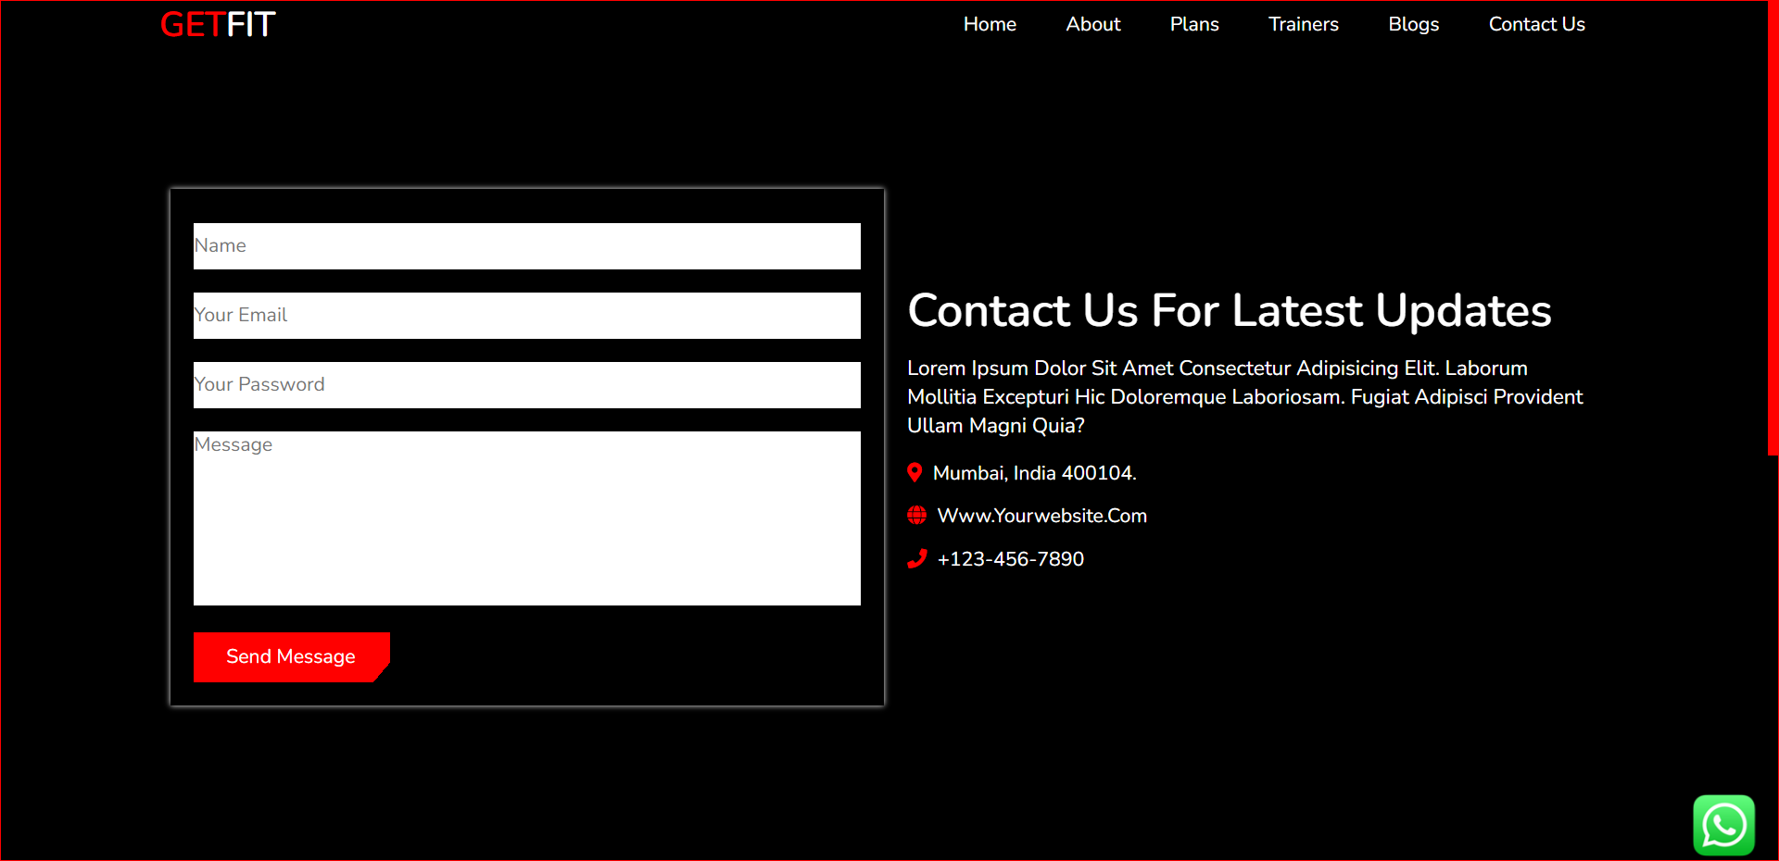

Chapter 6. Conclusion

The project report entitled "GETFIT Fitness Gym Responsive Website" has come to its final stage. The system has been developed with much care that it is free of errors and at the same time it is efficient and less time consuming.

The important thing is that the system is robust. I have tried my level best to make the site as dynamic as possible. Also provision is provided for future developments in the system. Any user can visit the website and gather the required amount of information.

The developed website is flexible and changes can be made easily. The website is developed with an insight into the necessary modification that may be required in the future. Hence the website can be maintained successfully without much rework.